**SaffronHealth.AI — Final MVP: Requirements + Hi‑Fi Wireframes**

Date: 09-Dec-2025 | Theme: Saffron Purple (Light) | Roles: Payer, Provider, Care Coordinator

This is the final, consolidated document. It contains the signed‑off requirements and the high‑fidelity wireframes with drill‑down explanations. **No external links are included.**

# Executive Summary

Build a clinician‑first, role‑based population health dashboard that reads patient data from a JSON dump and surfaces explainable, actionable insights for Payer, Provider, and Care Coordinator personas. The MVP focuses on UI, drill‑downs, and narratives. No backend APIs are required; all metrics are computed client‑side from JSON.

# 1. Scope & Objectives

• Role‑based workspaces with cohort filters and live KPIs  
• Explainable “Why?” evidence pills on every alert/tile  
• Drill‑down flows: KPI/driver → Cohort List → Member Drawer (Summary/Cost/Care/SDoH)  
• Narratives (Trend/Distribution/Care focus) to reduce cognitive load  
• Accessibility: WCAG AA contrast, keyboard shortcuts, high‑contrast provider mode

# 2. Personas & Primary Outcomes

**Payer:** Reduce avoidable acute spend; identify high‑cost cohorts; forecast 12‑month spend; share actionable cohorts.

**Provider:** Point‑of‑care snapshot with care gaps, HCC/CMI evidence, ED/Inpatient risk; document interventions quickly.

**Care Coordinator:** Triage SDoH + care gaps; send resources; assign/enroll pathway; track closure.

# 3. Data Source & Paths

Development path (Windows): C:\Users\mprasa30\Downloads\patient.json

Build/runtime path (Cloud Run): /public/patient.json

# 4. KPIs & Computations (from JSON)

• Total Members (count)

• Engaged Members % (Engaged/High Utilizer)

• Total Cost of Care (YTD): yearlySpending[2025] OR (edCostYtd + inpatientCostYtd + surgeryCostYtd)

• Preventable ED Spend (Modeled): sum(predictedEdCost) — chips from aggregated SDoH/Conditions

• Surgery Spend (YTD): sum(surgeryCostYtd); Projected Surgery: sum(predictedSurgeryCost)

• Risk Segment counts (Very High/High/Medium/Low)

• 12‑month Predictions: Total, ED, Inpatient, Surgery, Chronic, Other

• Cost Drivers: frequency‑weighted contributions (Oncology, MSK, Behavioral Health, COPD)

# 5. Cost Avoidance (MVP Formula & Tooltip)

Shown transparently in the tile tooltip:

Cost Avoidance = (Σ predictedEdCost + Σ predictedInpatientCost) − (Σ edCostYtd + Σ inpatientCostYtd)

Interpretation: Positive → modeled savings opportunity vs current YTD acute spend; Negative → acute spend exceeds projections.

# 6. Role‑Based Screens & Drill‑Downs

## 6.1 Payer Summary & Drill‑Down

KPIs: Total, Engaged %, YTD, Preventable ED (Modeled), Surgery YTD, Cost Avoidance.

Segments grid, 12‑month predictions, Cost Drivers chips; “Why?” pills show evidence from ed/inpatient/HCC/CMI explanations.

Flow: KPI/driver → Cohort List (virtualized 10k) → Member Drawer (Cost tab).

## 6.2 Provider Clinical Cockpit & Patient Timeline

KPIs: High‑risk visits today, Open care gaps, HCC opportunities (static wording for MVP), Abnormal trends.

Drawer tabs: Summary (careGaps, actionableRecommendations) · Utilization (edUseRisk, inpatientProbability, predicted split, YTD acute spends).

Actions: Confirm HCC/RAF (MVP flag), Add plan note, Mark gap planned.

## 6.3 Care Coordinator Workbench & Care Tab

Triage queue sorted by SDoH count → risk → lastUpdated. Care tab with checklist actions: Assign, Acknowledge, Enroll pathway.

SDoH & Resources: chips + copy/share links from communityResources.

# 7. Employee Finder, List & Details

Finder filters: State, Risk Segment, Condition, Engagement, SDoH (Housing/Food/Transport/Financial).

List: virtualized 10k; columns: Member, State, Risk, Risk Score, Conditions, SDoH chips, Engagement, Pred 12m Cost.

Row click opens Member Drawer (Summary/Cost/Care/SDoH) with “Why?” evidence pills.

# 8. Narratives & Explainability

Each KPI/alert includes a “Why?” pill showing top drivers and JSON evidence (hccRiskExplanation, cmiExplanation, edUseExplanation, inpatientExplanation).

Narratives: Trend, Distribution, Care focus—auto‑generated from segment mix and predicted acute utilization.

# 9. Accessibility & Performance

WCAG AA contrast; color + icon + text for status; keyboard shortcuts (g o / g l / g d; Esc).

Virtualized tables (react‑window) for 10k; memoized computations; cohort chips persist across tabs.

# 10. Implementation Plan (MVP, JSON‑only)

Stack: Next.js + React + TypeScript + Tailwind; ECharts; react‑window; Zustand state.

Data: JSON read via Node fs in dev; /public in build/runtime (Cloud Run).

Deliverables: Summary + Cohort filters; live KPIs; virtualized list; Member Drawer; “Why?” evidence; narratives; high‑contrast provider mode.

# Appendix: Hi‑Fi Wireframes (Color)

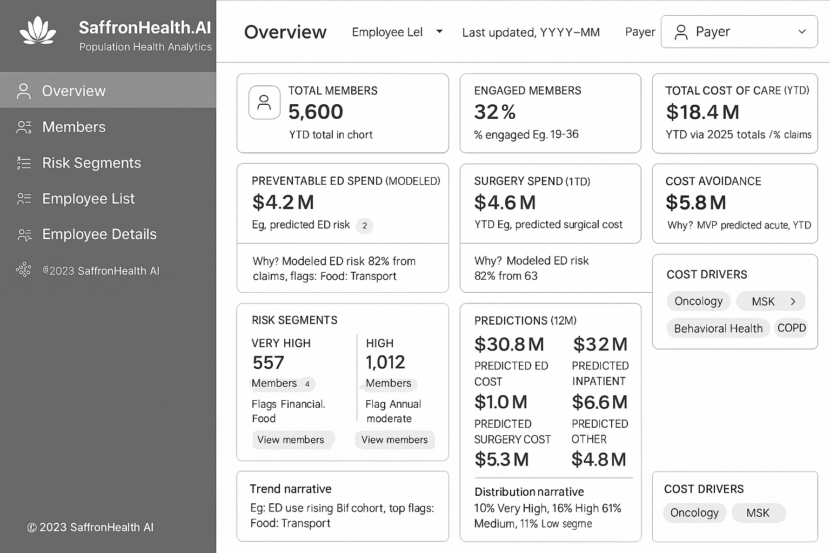

Payer Summary & Drill‑Down

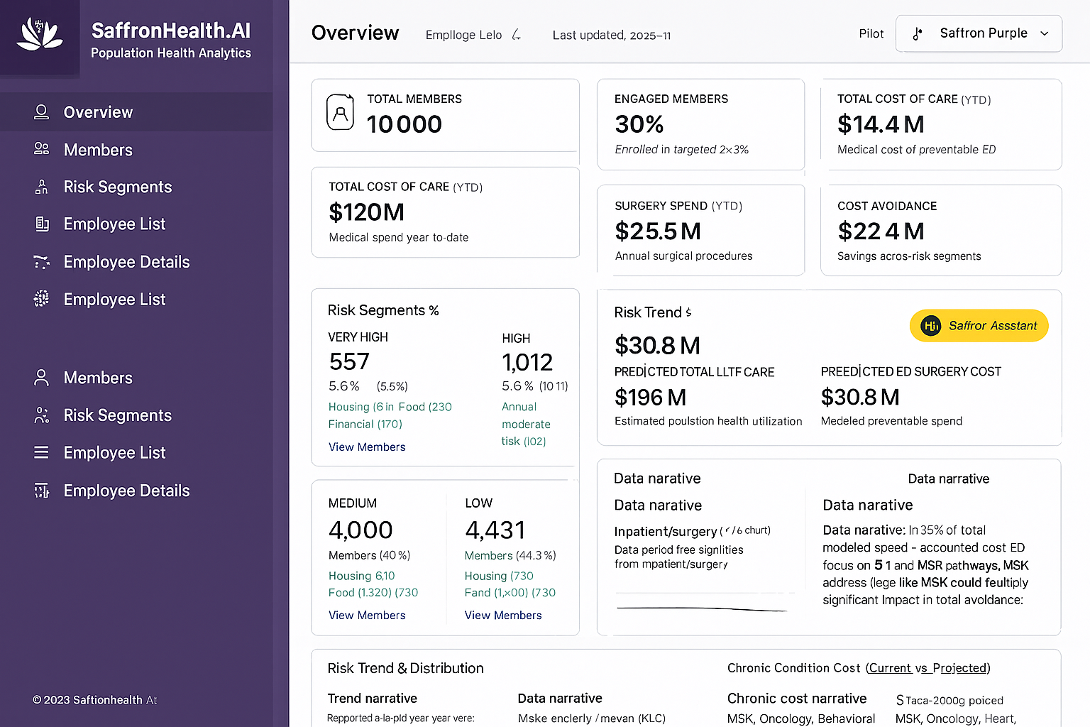

Provider Clinical Cockpit & Patient Timeline

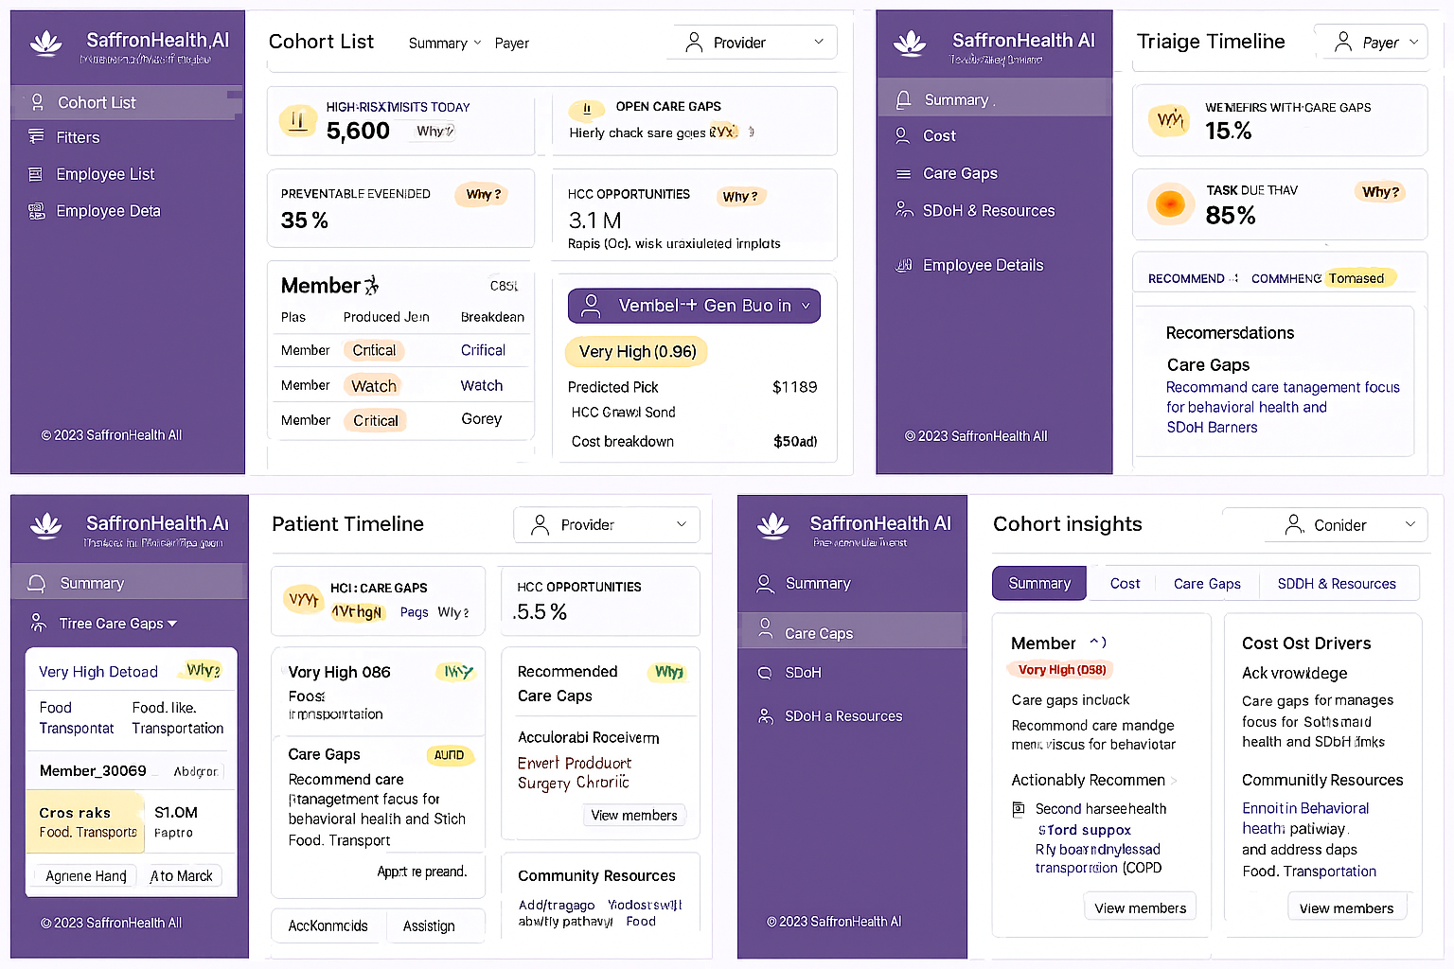

Care Coordinator Workbench & Care Tab

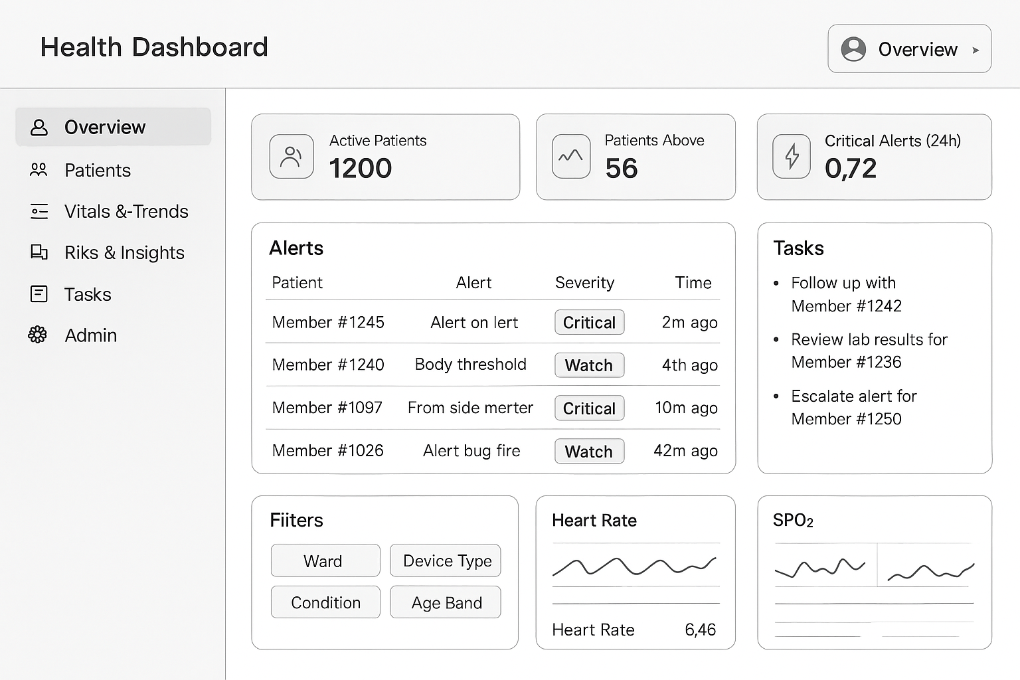

Employee Details & Cohort Insights

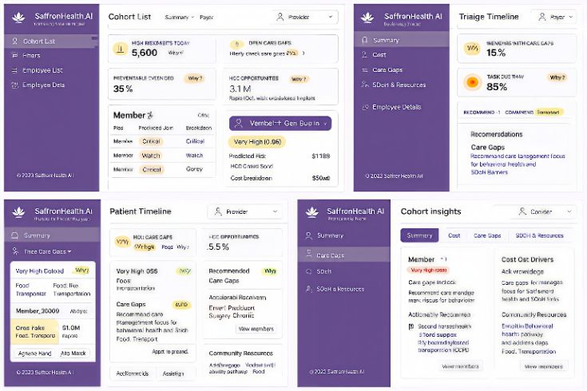

Composite drill‑down snapshot